**Usman Institute of Technology**

**Department of Computer Science**

**Spring 2025**

**Software Quality Engineering**

**Instructor: Sir Usman Waheed**

**Project: Audit Trail API**

|  |  |
| --- | --- |
| **Name of Student** | **Student ID** |
| Abhia Sultana | 22sp-026-se |
| Shahroz Kashif | 22sp-005-se |
| Areeba Ahmed | 22sp-050-se |

**Outline:**

**Audit-Trail Library API** logs and retrieves system actions (create/update/delete) for enhanced traceability and compliance. It offers structured audit entries—with timestamps, user identities, endpoints, old/new values—accessible via a clean interface. Benefits include data integrity, accountability, and ease of integration into any web application.

**Class Diagram:**

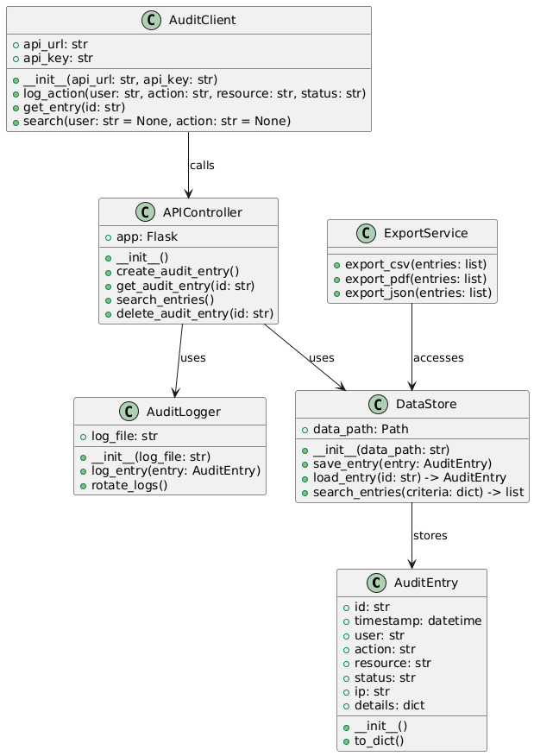

**Component Diagram:**

**Tutorials:**

### Installing & Initializing

* **Install** via Composer:

composer require shehrozkashif/audit-trail-library

* **Set up**: configure the database migration and run it:

php artisan migrate

* **Enable auditing** (e.g., in config/audit.php):

php artisan migrate

**2. Integrate With Your App**

* **Register middleware/service** in your framework’s bootstrap.
* **Annotate model changes**, record via:

AuditTrail::log('update', Auth::user()->id, $model, $old, $new, request()->url());

**3. Viewing Audit Logs**

* Use:

$logs = AuditTrail::forModel($model)->get();

**Authentication:**

• Uses your application's existing auth (e.g., Laravel’s Auth).

• Pass authenticated user ID when logging.

• Optional API token authentication can also be enforced per audit endpoint.

**Endpoint Definition:**

|  |  |  |
| --- | --- | --- |
| **Endpoint** | 1. **Method** | 1. **Description** |
| /audit | 1. GET | 1. Retrieve all audit entries |
| /audit/model/{id} | 1. GET | 1. Fetch logs for a specific model object |
| /audit/user/{id} | 1. GET | 1. List audits by user |

**Each returns JSON:**

**Status and Error Codes:**

**200 OK** — Successful request.

**401 Unauthorized** — No valid authentication.

**403 Forbidden** — User lacks permission.

**404 Not Found** — Model/user audit not found.

**500 Internal Server Error** — Unexpected server issue.

Each error returns details to aid debugging and resolution.

**Examples:**

**Successful fetch:**

GET /audit/model/101 HTTP/1.1

Authorization: Bearer <token>

**Response (200)**:

**Unauthorized access:**

GET /audit HTTP/1.1

**Response (401):**

**Glossary:**

* **AuditTrail** – Core class managing log operations.
* **Event** – Type of action: create, update, delete.
* **Old/New values** – Data snapshots before and after change.
* **URL** – API endpoint invoked.
* **User agent/IP** – Client and network metadata.
* **Model** – DB table/entity being audited.

**Audience & Journey:**

* **Developers**: need quick start guides, code snippets, endpoint usage.
* **Technical leads/Product managers**: require rationale (compliance, traceability), platform comparisons, integration benefits.

**User journeys covered:**

1. **Evaluation**: Outline & glossary help assess fit.
2. **Onboarding**: Tutorials and quickstart snippets ease setup.
3. **Daily use**: Endpoint documentation for integration into admin dashboards or reporting tools.

**Best Practices:**

* **Clear Language**: simple and direct documentation.
* **Comprehensive Reference**: full list of endpoints, parameters, and response formats.
* **Examples Everywhere**: for installs, config, calls, error states.
* **Ownership**: assign doc maintenance to a technical writer or developer.
* **Include Guides + References**: tutorials for use cases and full API specs side by side.
* **Sync docs with releases**: update docs during every feature/endpoint change.
* **Quickstart**: one-page guide to get working logs in minutes.